Offshore Wind

# Opening Activity: Site Suitability

**What criteria would you use to select the best location for building a new entertainment space in town?**

|  |
| --- |
|  |

# The Big Question

How will large-scale offshore wind projects transform Massachusetts’s energy sources?

# My Climate Goals

When you complete this lesson, you’ll be able to:

1. Describe how wind turbines capture energy and convert it into electricity
2. Identify examples of climate-critical professionals who work to design, build, and maintain offshore wind farms
3. Discuss how Massachusetts’s ports and other infrastructure contribute to the offshore wind industry.

**Notes:**

|  |
| --- |
|  |

# 

Massachusetts Port Evaluation

# Instructions

Analyze your assigned port’s current features to determine its suitability for supporting future offshore wind projects. If the port does not meet the criteria, identify specific upgrades that would allow it to be used in future offshore wind projects. Alternatively, identify other ways your port could support offshore wind project infrastructure.

|  |  |
| --- | --- |
| Criteria | Minimum Required |
| Water depth | 35 feet; ability to reach 35 feet through dredging |
| Heavy-duty wharves | Support up to 2,800 tons |
| Lay-down areas | 10 acres available |
| Proximity to project sites | Within 100 miles of proposed offshore wind sites |
| Environmental impact | Able to undergo upgrades with minimal disruption to surrounding marine ecosystems |

# Evaluation Prompts

**Based on your evaluation, could this port support offshore wind projects?**

|  |
| --- |
|  |

**What upgrades would you recommend?**

|  |
| --- |
|  |

**In what other ways could this port support MA’s clean energy goals?**

|  |
| --- |
|  |

**How might investing in port infrastructure contribute to MA’s clean energy goals?**

|  |
| --- |
|  |

**Notes for presentation:**

|  |
| --- |
|  |

## Charleston Navy Yard

Overview: The Charlestown Navy Yard, located in Boston’s Charlestown neighborhood, is a historic port. It was first used for building and repairing navy ships, but now it houses museums, businesses, and docks. Some parts of the yard have been upgraded for visitors, but the infrastructure remains old and unsuitable for industrial projects like offshore wind energy farms.

Details:

* The water depth is 32 feet, but sediment buildup has made some areas shallower.
* The wharves can hold loads weighing up to 1,500 tons.
* It has six acres of open space, which is mainly used for seasonal shops, parking, and events.
* The navy yard is 90 miles from the proposed offshore wind project sites.
* The area is busy with ferries and tourist boats.
* The navy yard is a historic site with limits on construction changes.
* There’s a neighborhood nearby, and residents might oppose industrial projects.

**Notes:**

|  |
| --- |
|  |

## Mystic River Terminal

Overview: The Mystic River Terminal is an industrial port in Everett, MA. It is very active and mainly used for transporting bulk cargo such as petroleum and chemicals. It has modern facilities but was designed for bulk cargo rather than large construction projects.

Details:

* The water depth is 37 feet, with some areas being shallower due to sediment.
* The wharves can support loads weighing up to 2,000 tons.
* The terminal has eight acres of open space, which is mostly used for shipping containers and bulk materials.
* The Mystic River Terminal is 95 miles from the wind project sites.
* The river’s narrow channels may limit access.
* The terminal is near protected marshlands.
* Local residents have voiced concerns about pollution from current operations.

**Notes:**

|  |
| --- |
|  |

## Conley Terminal



Overview: Conley Terminal in South Boston is a container port that handles many international shipments. It recently received upgrades, making it one of the most modern ports in the area. The port primarily handles container shipments, with limited space for non-container activities.

Details:

* Conley Terminal’s water depth is 40 feet.
* The wharves can hold 3,000 tons.
* There are four acres of lay-down area available.
* Conley Terminal is 75 miles from the offshore wind project sites.
* Major shipping lanes make transport to wind farm sites relatively easy.
* The high volume of container operations limits flexibility for new uses, as reducing container space would impact port business.
* The port is near a busy highway, which helps overland access but can cause traffic delays.

**Notes:**

|  |
| --- |
|  |

## East Boston Terminal

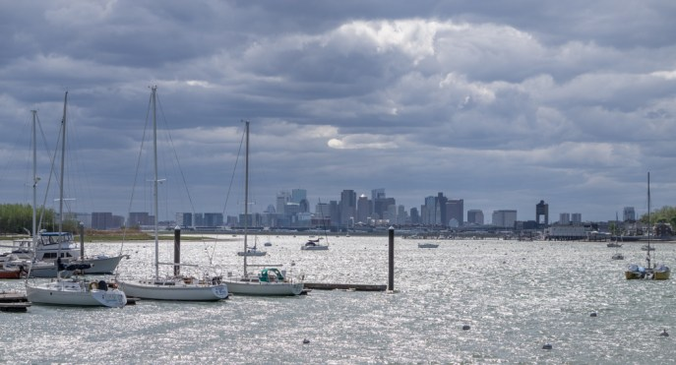

Overview: East Boston Terminal is located across the harbor from downtown Boston. This port mainly supports smaller shipments and local businesses. As the area around the port grows with new homes and businesses, expansions are limited.

Details:

* The depth is about 30 feet.
* The wharves can handle loads of up to 1,500 tons.
* There are three acres of open area primarily used by local businesses.
* The port is 85 miles from the proposed wind energy project sites.
* The route between this port and the project sites crosses high-traffic areas.
* The port is close to a neighborhood that may oppose significant expansions.
* East Boston is growing, which could make large industrial projects less desirable.

**Notes:**

|  |
| --- |
|  |

# Lesson Key Points

* Wind turbines convert wind energy into electricity.
* Offshore wind supports Massachusetts’s clean energy and economic goals.
* Ports like New Bedford and Salem are vital to offshore wind.

**Additional key points:**

|  |
| --- |
|  |

# Closing Activity

**What did you learn about offshore wind power today that surprised you?**

|  |
| --- |
|  |

**Why are Massachusetts’s ports vital to the offshore wind industry?**

|  |
| --- |
|  |

**Careers of interest you heard about in this lesson:**

|  |
| --- |
|  |